Faculty of Technology Careers Advisers

  Alison Skellern  Careers Consultant | 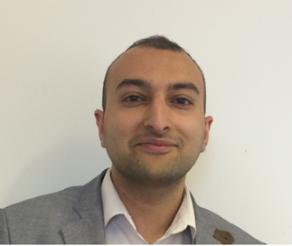  Amardeep Panaser  Employability Officer
How to get in touch with us:  Email: techcareers@dmu.ac.uk for Careers-related queries and E-guidance  Website: www.dmu.ac.uk/careers  MyGateway online portal:  https://mygateway.dmu.ac.uk/  1:1 appointments in the Student Gateway: Log on to MyGateway to book a 30-minute Careers appointment  (11am – 3pm, Monday – Friday).  Faculty of Technology 1:1 appointments (FOT Careers):  Tuesdays 10am – 12pm  Wednesday 3 – 5pm  (Check MyGateway for dates and rooms, and to book a 30-minute appointment)  Telephone: 0116 2577595 | We can help you with:  - Finding jobs, internships and work experience  - Making career decisions  - Applications, CVs and interviews  - Planning your next step  - Promoting yourself to employers  - Creating a positive online presence, and using social media to improve your employability  - Further study options and funding  - Self-employment  Events (including workshops, employer presentations and Career Fairs):  https://mygateway.dmu.ac.uk/students/events
You can use the service all year round (including university holidays) and for as long as you need after graduating

